Hands-On Activities to Teach Your Preschooler About the Environment

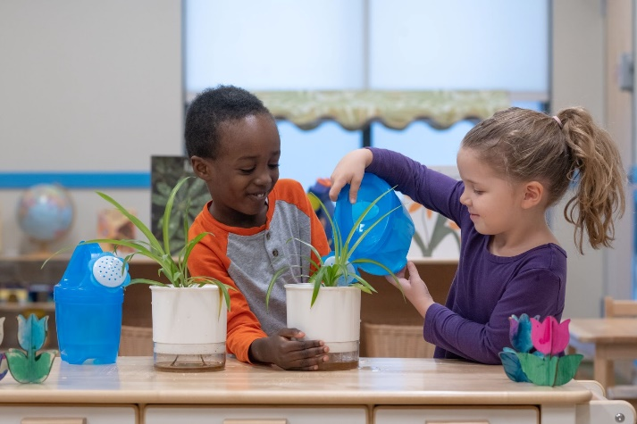
Children are programmed to explore and experiment with their environment from the very beginning, even as infants. The Scientific Exploration component of our Links to Learning curriculum supports the development of scientific inquiry and expands upon children’s natural curiosity. Science activities develop many important life skills, but the most important benefit for young children is teaching them how to think and develop a sense of curiosity and wonder.

Below are some hands-on, age-appropriate activities to spark wonder and learning in your child.

Infants (0-1 year)
Provide toys that have incremental sizes (nesting cups, stacking rings) and toys that allow for the discovery of cause and effect (pop-up toys, interactive sound books).

Toddlers (1-2 years)
Encourage your child to observe and explore natural materials indoors and outdoors. Make a telescope using a paper towel tube and encourage them to look for certain objects. For example, ask, “Do you see anything that is green?” or “Can you find any insects?”

Beginners (2-3 years)
Involve your child in observing events in nature and discuss the observations. Make a birdfeeder to hang in your backyard and ask your child “What is the bird doing?” or “Can you tell me what you see?”.

Intermediates (3-4 years)
Help your child learn about the five senses: see, hear, smell, taste, and touch. Encourage them to use their five senses when exploring objects. Go for a nature walk and listen to birds, look at the shape, color and speed of the clouds, smell the pine-scented air, feel the rough bark.

Pre-K/Pre-K 2 (4-5 years)
Build new structures with your child using various materials such as empty boxes or coffee cans, sticks, cardboard tubes, etc. Talk about what you see your child doing as they are building and ask open-ended questions.

Something for all ages!
Find opportunities to talk about the weather every day and make it relevant to your child’s real-life experiences and routines. An example for younger children is, “It’s cold outside. We will need to put on our hats, gloves, and coats before we go to the playground.” Once your child is old enough, have them evaluate the weather each morning. Based on their evaluations, allow them to determine what clothes to wear. Talk about the different choices of apparel and why they may or may not be appropriate.

