Celebrating 40 Years: Chesterbrook Academy
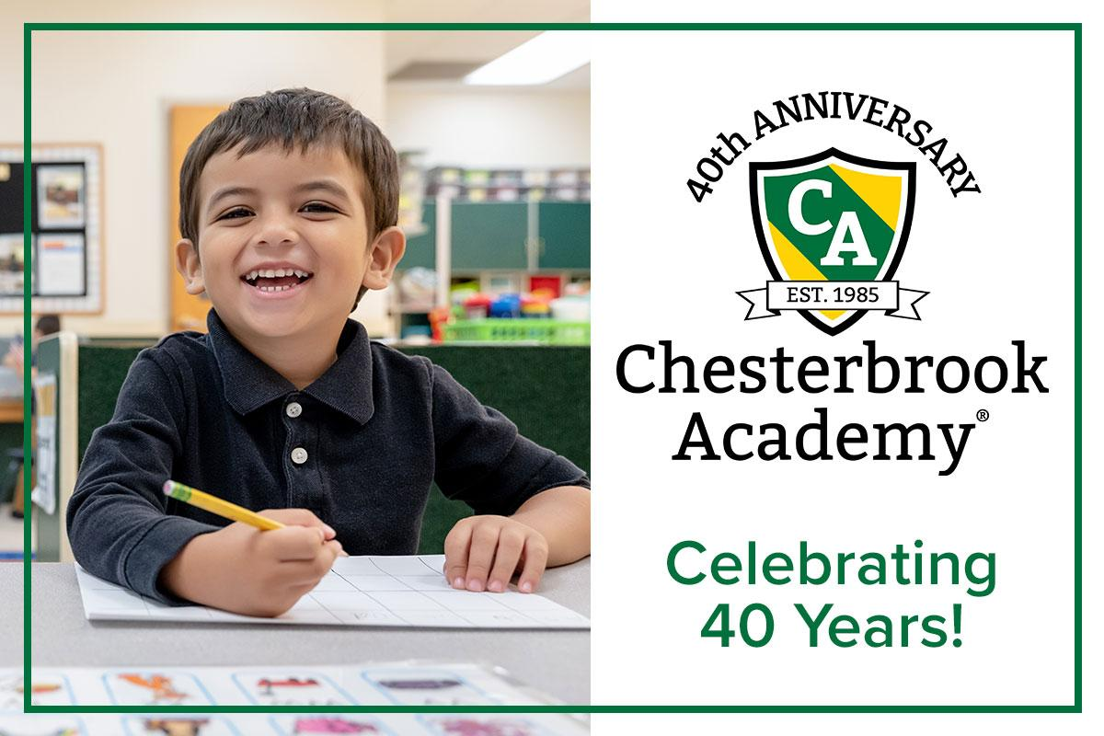
Where Learning Lasts a Lifetime
Chesterbrook Academy proudly celebrates 40 years of educating, nurturing, and inspiring children from infants through eighth grade!
Since opening our first campus in 1985, we’ve had the privilege of guiding nearly 100,000 students through the most important steps of their educational journey. From preschool through middle school, we provide a supportive and challenging environment where students grow academically, socially, and emotionally. We help students build the foundation for their future success in school and in life.
A Legacy of Excellence in Education Since 1985
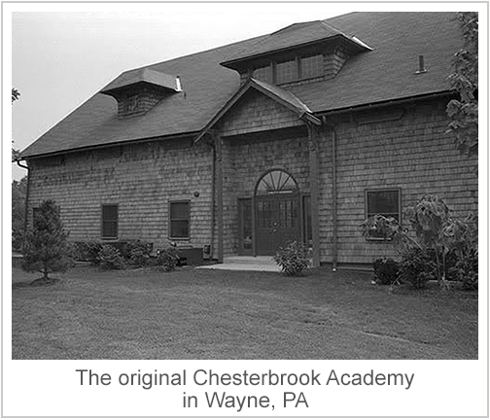
Chesterbrook Academy traces its roots to Chesterbrook Farm in Wayne, Pennsylvania, a historic property owned initially by Pennsylvania Railroad executive Alexander J. Cassatt. In 1985, Rocking Horse Child Care Centers of America (RHCCCA) transformed the property into a preschool, marking the start of Chesterbrook Academy. The school quickly distinguished itself by offering high-quality, curriculum-based preschool education rather than traditional daycare services.
This focus on curriculum and quality attracted a growing number of students and families to Chesterbrook Academy. In response to this demand, Chesterbrook Academy began expanding into new geographies while thoughtfully clustering schools together to facilitate higher-quality operations through shared support of the schools. Chesterbrook Academy began opening preschools beyond Pennsylvania in 1986, expanding into Illinois, New Jersey, North Carolina, Virginia, South Carolina, Florida, and Maryland over the following years. Building on the success and impact of our preschools, Chesterbrook Academy expanded to elementary and middle schools, providing older students with the same high-quality, challenging educational experiences.
Today, Chesterbrook Academy serves children from 6 weeks old through 8th grade. Though its name honors a historic farm, its legacy is rooted in delivering exceptional education to children. Chesterbrook Academy has fostered academic excellence, character development, and a lifelong love of learning in nearly 100,000 students across America since 1985.

What Sets Us Apart
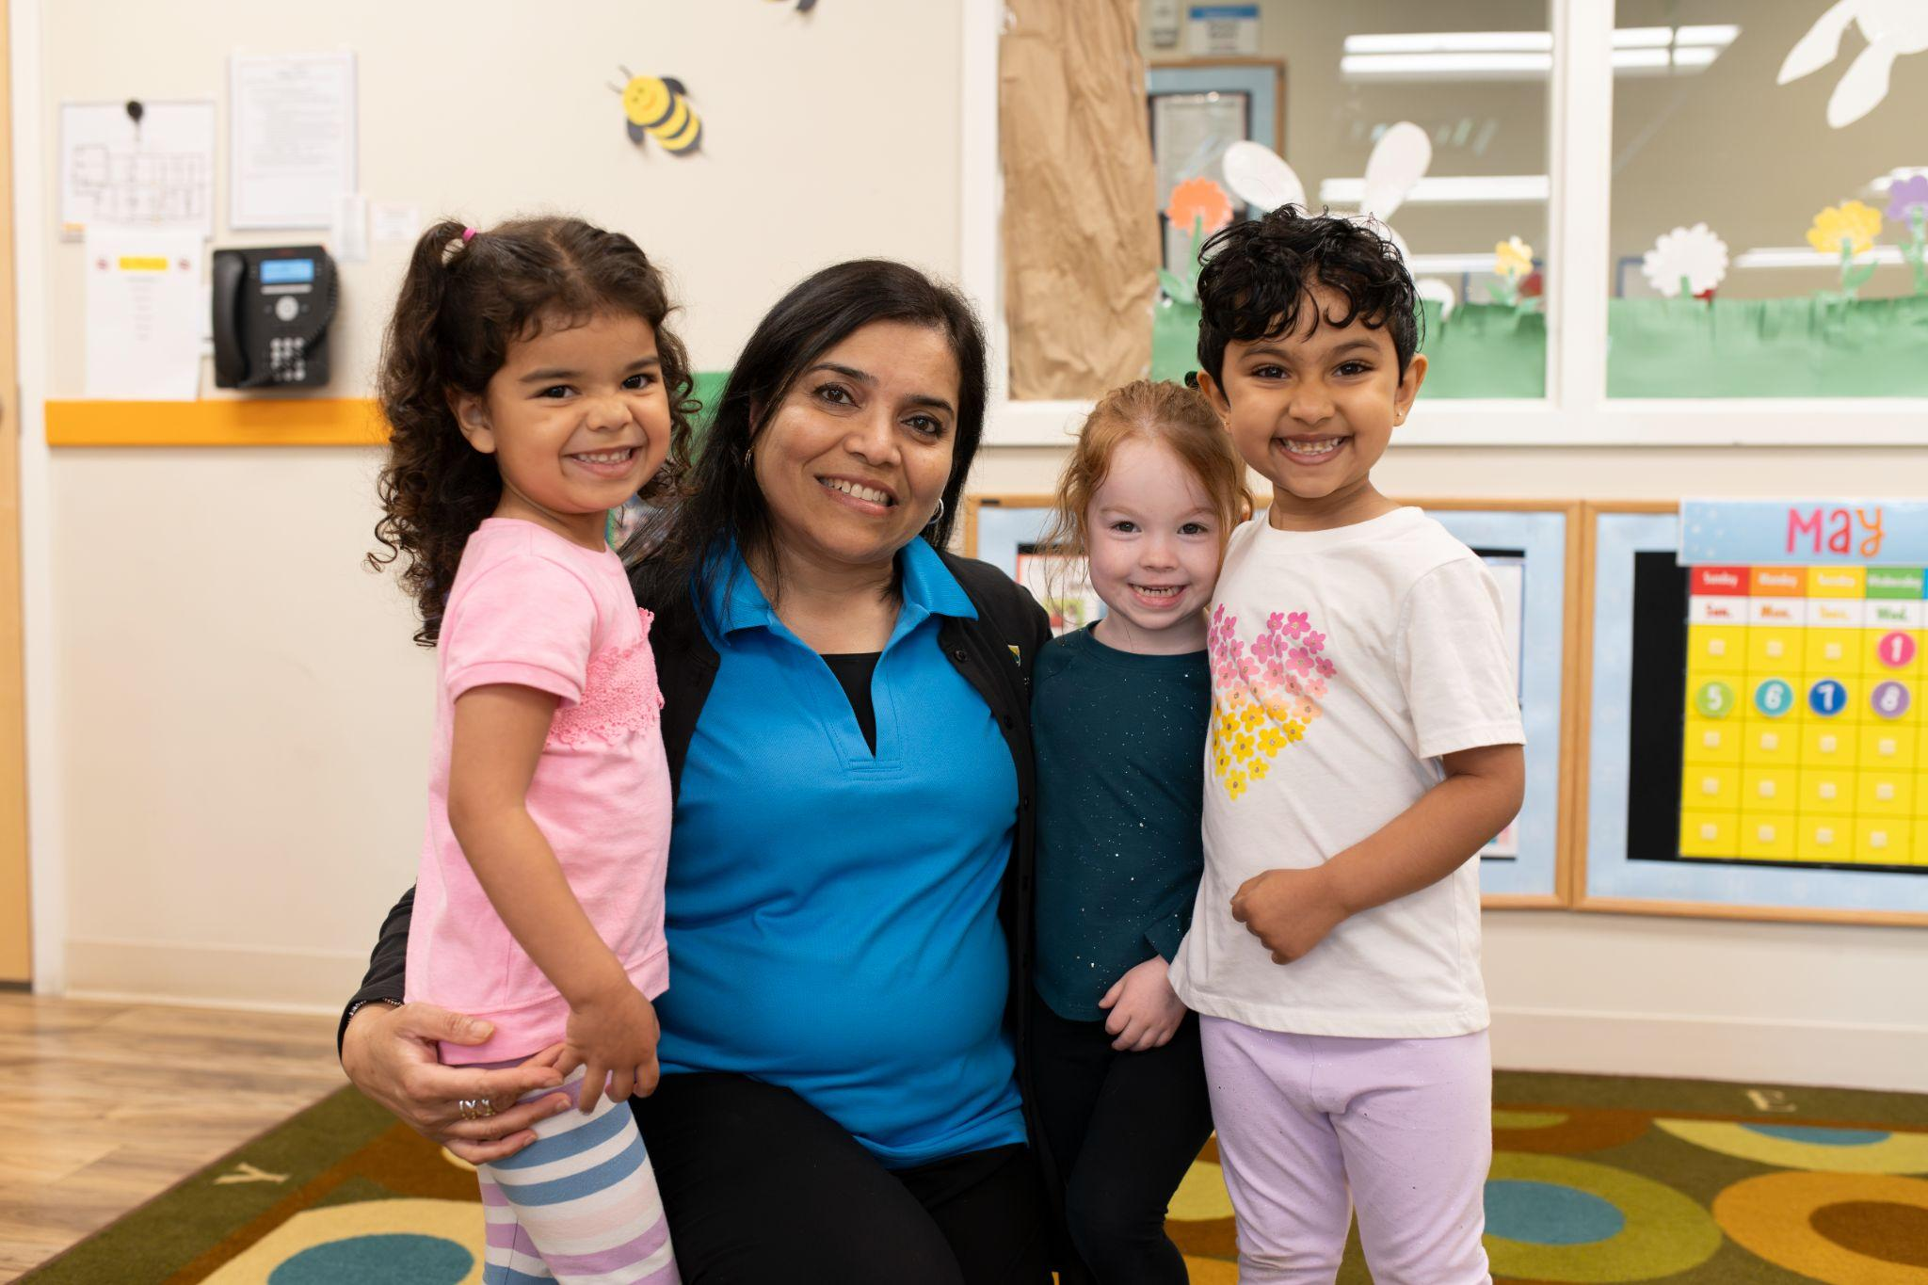
At Chesterbrook Academy, children thrive because our classrooms combine academic excellence with hands-on, small-group learning and individualized support. Our teachers build strong relationships, celebrate each child’s strengths, and guide students through developmentally appropriate challenges that inspire critical thinking. Every day, children practice empathy, responsibility, and respect as they develop the academic skills and confidence needed to succeed in school and beyond.
As our preschool students develop into elementary and middle school students, this educational foundation allows them to consistently earn some of the highest scores among independent schools on the Comprehension Testing Program. This distinction reflects the strength of our rigorous curriculum, the expertise of our faculty, and the intellectual curiosity our students bring to every classroom.

Learning with Purpose: A Curriculum That Connects
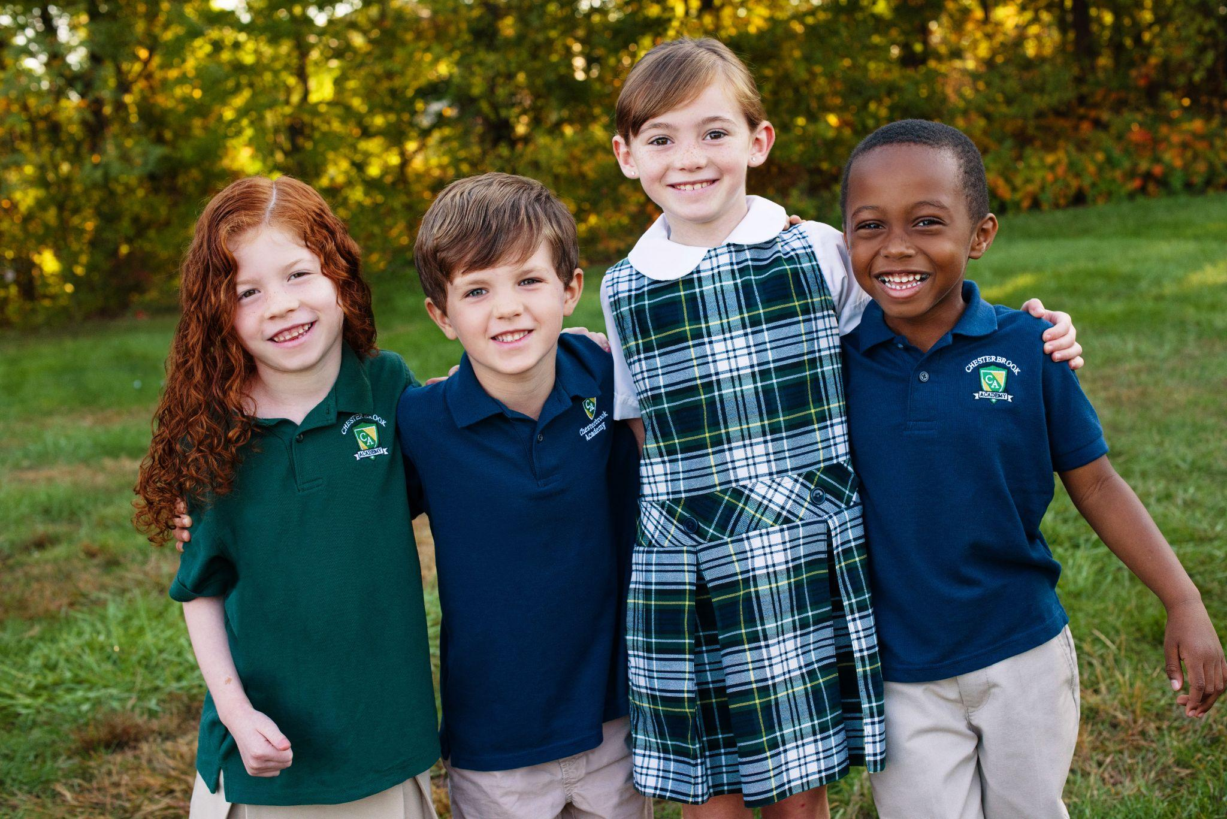
At Chesterbrook Academy, learning evolves as our students grow, from the foundation built in preschool to the independence and curiosity fostered in middle school.
In the early years, our Links to Learning® curriculum builds the foundation for future success. Through hands-on exploration, small-group activities, and personalized instruction, children gain early literacy, math principles, and problem-solving skills, while also learning to collaborate as good students and friends, and express themselves respectfully. Families stay engaged through our Links 2 Home® app, weekly newsletter updates, and ongoing communication.
As students move into elementary and middle school, our approach becomes more dynamic, student-centered, and appropriately rigorous. Students are empowered to dig deeper into concepts through collaborative projects, immersive experiences, and classes that inspire both creativity and confidence. Our teachers combine high expectations with meaningful support, ensuring every Chesterbrook Academy graduate is prepared to thrive in their next level of education. Chesterbrook Academy elementary and middle school students rise to the challenge of their academics, enjoy project-based learning, and participate in academic competitions in math and science.
40 Years and Just Getting Started

Over the past four decades, Chesterbrook Academy has remained committed to providing children with the educational experience they deserve. We’ve celebrated milestones, welcomed thousands of families into our school communities, and watched countless students take their first steps toward a lifelong love of learning.

From their first days in the classroom to the elementary years and beyond, our families share what Chesterbrook Academy has meant to them.
“Upon starting kindergarten in the fall, it was clear to us how well prepared our son was thanks to the curriculum at Chesterbrook Academy. Not only was he academically prepared, he was emotionally prepared as well!” - Gabrielle K., former Pre-K parent
“From the start, students explore STEM subjects in an engaging, hands-on way that sparks curiosity and builds a strong foundation. The teachers and administrative staff are the best we’ve ever encountered—passionate, professional, supportive, and genuinely invested in each child’s success.” - David J., 7th grade parent
As we look to the future, our commitment is stronger than ever. We’ll continue to grow, evolve, and innovate, always grounded in our belief that every child deserves to feel safe, engaged, and inspired.
To our teachers, families, and students, THANK YOU! You are the heart of Chesterbrook Academy. We are grateful to share this journey with you. Here’s to 40 more years of learning and growing together!

