Celebrating Fall: Crafts and Activities for Your Preschooler
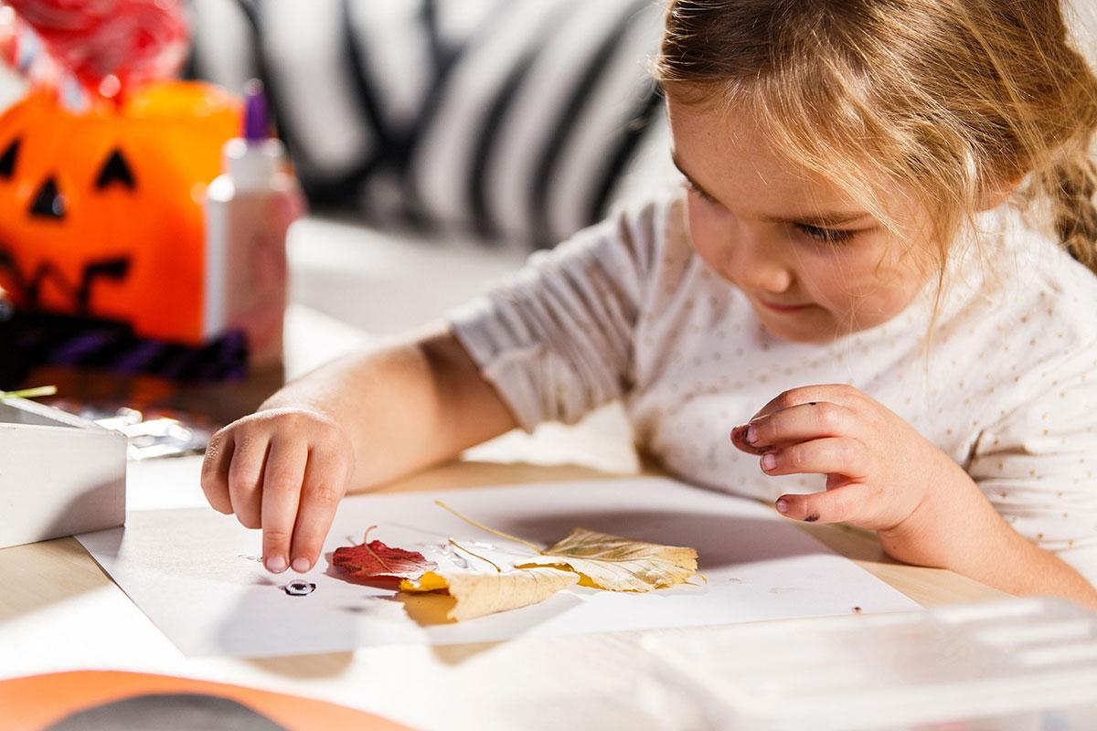
Fall is here! The leaves are changing, the air is crisp, and it’s the perfect time for some fall fun with crafts and activities. From pumpkin projects to apple treats, all paired with seasonal book recommendations, these activities are designed to delight your preschooler, spark creativity, and create joyful memories to treasure.

Create Leaf Art
Go on a leaf scavenger hunt, inviting your child to collect their favorites. Then, head inside and gather some construction paper and glue. Ask your child to create leaf art by gluing their leaves onto the paper to create simple collages and designs, or more distinct images like animals or people. Encourage them to take their time, talk about their creations, and even write or tell a story about their picture.

Book Suggestion: Leaf Man by Lois Ehlert - A beautiful picture book showing all sorts of images created by leaves.

Make Fall Lanterns
You’ll need some small, soft leaves, a plastic decorative jar or glass mason jar, and child-friendly Mod Podge. Have your child “paint” the back of each leaf and press them onto the jar. Let those dry, then add another layer of Mod Podge over the leaves and jar. Once everything dries, place a battery-operated candle inside, and your child will have a beautiful and warm seasonal light for their bedroom. *For easier application, you can also use fall-colored tissue paper leaves.

Book Suggestion: If You Find a Leaf by Aimée Sicuro - Similar to Leaf Man with its imagery, but the end of the story shows a leaf campfire and a child sleeping in their bedroom with a lamp beside them.

Go apple picking and make apple pie cups
Once your child has harvested apples, chop them up into small pieces. In a muffin tin, have your child place pre-made biscuit dough. Next, your child can mix the apples with cinnamon and sugar, then place the mixture in each cup. Bake at 375°F for 15–20 minutes, or until the pastry is golden and the apples are tender. Enjoy!

Book Suggestion: Apple Farmer Annie by Monica Wellington - Follow along as Annie tends to her orchard, harvests apples, and bakes delicious apple treats.

Dramatic Play: Farmers Market or Pumpkin Farm
Take a trip to the farmers market or pumpkin farm, and have your child pick out some small pumpkins, gourds, and apples. Supply your child with some bins for their produce and encourage them to set up a small shop, kitchen, or farm of their own. You can also challenge them to sort their goods by shape, color, size, or type.

Book Suggestion: Pumpkins and Apples by Anne Rockwell - A young girl and her parents visit a local farm to pick apples and choose the perfect pumpkin.

Make Pumpkin Ornaments
Directions for making salt dough can easily be found online. Have your child help you mix the dough and create the pumpkin shapes, then press their handprint onto it. Once it’s dry, they can paint the pumpkin orange and add a green stem. A special treat for you as you now have a keepsake to treasure forever!

Book Suggestion: The Legend of Spookley the Square Pumpkin by Joe Troiano. Spookley the Square Pumpkin learns that being different is something to celebrate. After reading the story, talk with your child about how everyone is different, and that’s a good thing! Notice that no two fingerprints are the same and compare each other's fingerprints.

Pumpkin Playdough
Mix 1 cup canned pumpkin puree, 1/2 cup cornstarch, 1/2 cup all-purpose flour, 2 teaspoons pumpkin pie spice, and 1 tablespoon of vegetable oil. Mix and knead until a dough forms. If it’s too wet or sticky, you can add more flour. Once it’s ready, your child will enjoy the scents of fall as they work with the dough. You can also provide your child with fall-themed cookie cutters such as leaves, pumpkins, and acorns.

Book Suggestion: The Smell of Fall by Mary Ann Hake - April, who is blind, explores the autumn season by experiencing its rich scents, from the crisp air at school to the earthy aromas on a farm, celebrating the beauty of fall.

Have a Spooky Story Night
Create a warm ambiance with a lit fireplace, candles, or twinkle lights. Gather up some cozy blankets and pillows and a flashlight. Read some spooky (but not too scary!) stories as a family. Encourage your child to make up their own spooky story, too! They can even use props like a pumpkin or broom to act out their story. This would be fun to pair with themed snacks or Halloween treats.

Book Suggestions: Room on the Broom by Julia Donaldson, The Little Old Lady Who Was Not Afraid of Anything by Linda Williams, and Click, Clack, Boo!: A Tricky Treat by Doreen Cronin - all bringing spooky twists and fun!

Make Jack-0-Lantern Rocks
Children love to decorate pumpkins. Decorating rocks instead makes the fun last longer! Collect some smooth rocks from your yard, then wash and dry them. Next, have your child paint them orange. Once dry, your child can add all kinds of jack-o-lantern faces! They’ll really love it if you sit beside them and make some jack-o-lanterns as well. Washable markers will get the job done, but for more vibrant faces, and if you're brave, paint markers work great.

Book Suggestion: Ten Little Jack O Lanterns by Amanda Sobotka - A fun, counting story where ten pumpkins disappear one by one, leading up to a spooky Halloween surprise!

