7 Books to Celebrate Native American History
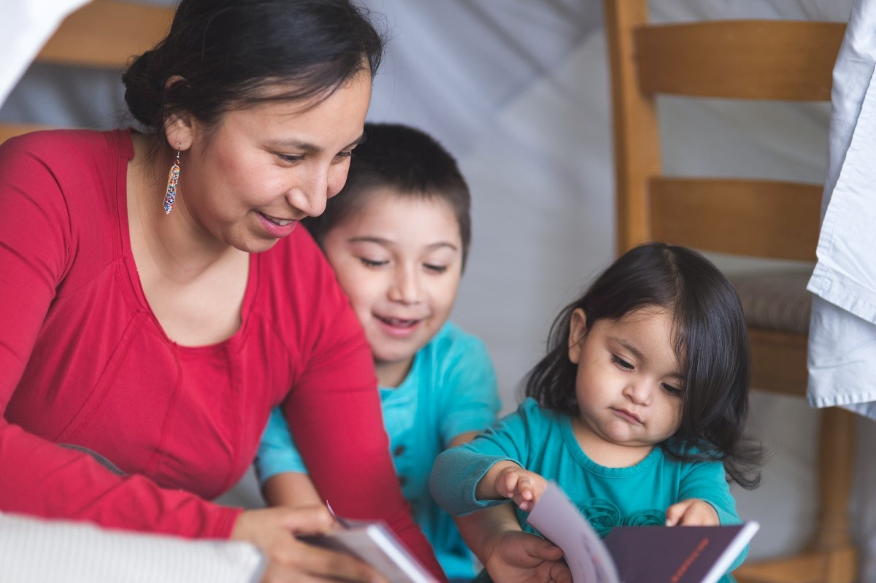
Reading can open a window into new worlds. This November, we celebrate Native American History Month with books that teach children about family, community, and our connection to nature. Each story shares lessons in gratitude, kindness, and the traditions of Native peoples.

Fry Bread by Kevin Noble Maillard
Fry bread is more than beloved food. It embodies history, family, and more. Through this story, children can see how food connects us to people and culture.

We Are Grateful: Otsaliheliga by Traci Sorell
In this story, we journey with the Cherokee people through a year of seasons, expressing thanks for each one. Children learn about meaningful ceremonies, joyful celebrations, and traditional foods. This book teaches the value of gratitude while immersing readers in the Cherokee language and culture.

My Heart Fills with Happiness by Monique Gray Smith
Through the perspective of a young Native American child, this story celebrates the simple moments that bring children joy, such as seeing the face of someone they love, feeling the warmth of sunlight on their skin, and walking barefoot on the grass.

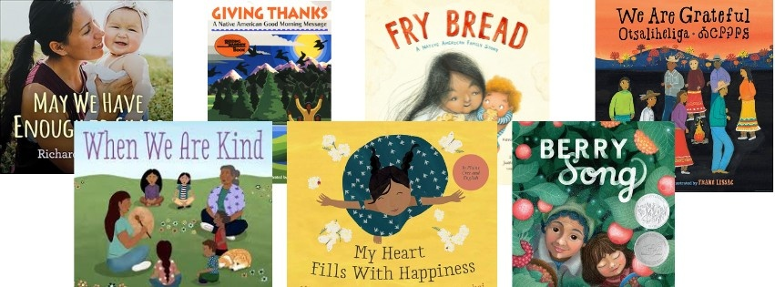

When We are Kind by Monique Gray Smith
This gentle story shows children many simple yet powerful ways to show kindness. It explores how small acts of kindness can brighten someone’s day, and make their own hearts feel happy with joy and warmth.

May We Have Enough to Share by Richard Van Camp
This beautifully crafted board book features striking photographs by Indigenous women, each page expressing heartfelt wishes such as “May we have enough to share” or “May we have enough to help.” Through its images and words, the book celebrates themes of love, nature, and community, making it both a visually stunning and deeply meaningful read for young children.

Berry Song by Michaela Goade
A young Tlingit girl and her grandmother gather gifts from the earth. As they work, they sing to the land and give thanks for its abundance. This beautifully told story highlights the deep connection between people and nature.

Giving Thanks: A Native American Good Morning Message by Chief Jake Swamp (Tekaronianeken)
This book shares a daily message of gratitude drawn from the Haudenosaunee (Iroquois) Thanksgiving Address. Each page gives thanks to the earth, plants, animals, and people, while teaching children about the profound interconnectedness of all life. It is a wonderful way to begin or end the day with gratitude and mindfulness.

At our school, we believe children benefit from learning about the many cultures and traditions that shape our world. Books, meaningful discussions, and intentional, engaging hands-on experiences help students explore different ways of life. They embrace and honor the qualities that make each person unique, cultivating empathy and a deep respect that inspires them to understand and care for others.

To learn more about how we bring cultural learning to life in the classroom, contact us today!

