Celebrating Diversity and Growing Kindness in Our Preschool
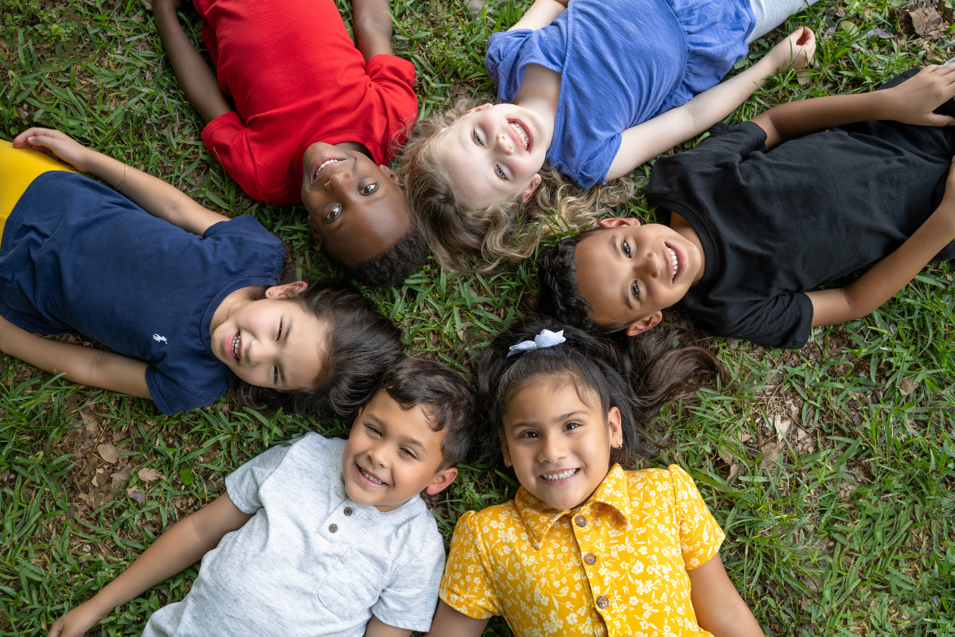
Diversity makes our world a beautiful and interesting place, and we believe it should be celebrated from the very start. At our preschool, children learn about the cultures and traditions within our own community, as well as those from around the world. When young children explore both differences and similarities, they begin to understand that while people may look, speak, dress, or live in many ways, we all share the same need for kindness, respect, and connection.

Learning about other people and ways of life helps children grow into caring, thoughtful individuals. It builds empathy, encourages curiosity, and teaches respect for others. Below are a few of the ways we bring these important lessons to life in our classrooms each day.

Citizens of the World
Citizens of the World is the social studies part of our curriculum. Through stories, pictures, discussions, and hands-on activities, children learn about different places, people, and traditions. They explore holidays, family life, and daily routines from cultures around the world. They may taste new foods, listen to folktales, or explore traditional clothing from other countries. These experiences help them build respect for others and understand that every culture has value. Over time, they begin to see themselves as part of a larger world.

Classroom Spaces That Reflect Every Child
Our classrooms are designed to help every child feel seen and valued. Our libraries include books that reflect families of many backgrounds and ways of life. Children often create class books about their families, and photos from home are proudly displayed on our walls.

When children recognize their own lives and cultures in the classroom, it helps build confidence and a strong sense of belonging. It also teaches them that while families may be different, love and care look the same everywhere. These simple touches help create a warm, inclusive community where every child feels welcome.

Learning Through the Creative Arts

Dramatic Play - In our dramatic play centers, children use their imaginations to explore the world. They dress up, take on new roles, and work together to act out real-life experiences. One day, this space might become a kitchen where students make tamales, another day an igloo in the Arctic, a Native American wigwam, or a stage for sharing important messages like those of Dr. Martin Luther King, Jr.!

Art - Our students learn about artists from many cultures and time periods, such as Alma Thomas and Vincent van Gogh. They explore different art techniques and use a variety of materials and tools to create and express their ideas. For example, they might make clay pots with play dough after learning about Japanese Raku or paint water lilies inspired by Claude Monet’s work. Students sometimes create art while listening to music from around the world, allowing the sounds to influence their art.

Music - Music is a joyful way to explore culture. Children dance to songs from different countries and try instruments from around the world. You might hear maracas shaking during a lesson about Mexico or drums playing as children learn about African music traditions.

Sharing Stories and Building Understanding
During morning and afternoon circle time, children talk about what makes them special. They share stories about their families, favorite foods, holidays, and daily routines. Listening to one another helps children learn to respect different experiences and feel proud of their own.

Growing Kind Hearts and Open Minds
When children learn about people and cultures from around the world, they become more curious and open to new ideas. They practice sharing, listening, and working with others who may be different from them. They begin to see that every person brings something special to the world.

To learn more about how we bring the world into our classrooms, contact us today!

