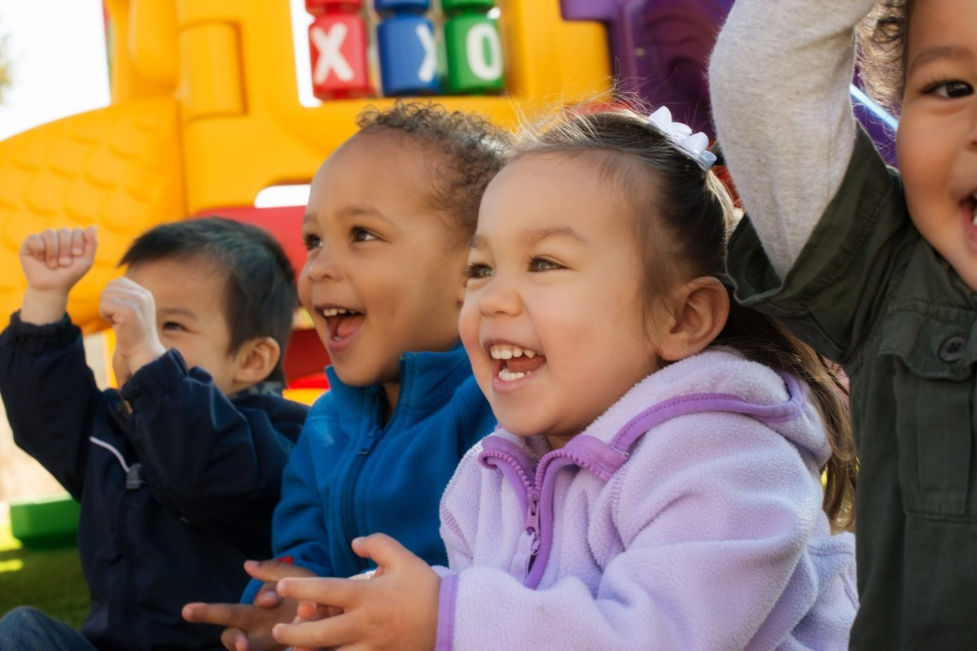
Week of the Young Child: A Celebration of Early Education
Week of the Young Child (WOYC), sponsored by the National Association for the Education of Young Children (NAEYC), is a special celebration that highlights the importance of early childhood education, the amazing young learners in our care, and the people who support them.
During this exciting week, learning comes to life with themed days like Music Monday, Tasty Tuesday, Work Together Wednesday, Artsy Thursday, and Family Friday. Each theme sparks fun, hands-on activities that mirror the meaningful moments happening in our classrooms every day, all inspired by our Links to Learning curriculum. As we celebrate, we reaffirm our commitment to giving every child engaging early experiences that build a strong foundation for the future.
To learn more about the importance of early childhood education and WOYC, we’re speaking with Gilda Villaflores from our Education Team. With over 20 years of experience in early childhood education, Gilda brings a strong background as a teacher, mentor, and director.
Hi, Gilda. Can you explain why early childhood education is so important?
Early childhood education is crucial because it lays the foundation for a child’s lifelong learning. It helps children develop language, social-emotional, and cognitive skills through play, exploration, and guided experiences. These early years are a time of rapid brain development, and quality learning environments give children the confidence and skills they need in school and beyond.

Can you share what Week of the Young Child celebrations look like in our classrooms?
We celebrate this important week with hands-on activities that spark curiosity and joy. Children explore fresh, exciting ideas through music, cooking, art, building, and play, practicing important skills along the way. We also take time to honor our educators for their dedication and care. The week is filled with learning, teamwork, and fun!
How does Week of the Young Child foster social-emotional skills?
Through music activities, children engage in group experiences and express themselves. Collaborative projects—such as cooking, building, or creating art together—encourage sharing, patience, and problem-solving. By celebrating families and school communities, children develop a strong sense of self, belonging, and connection.
How are language & literacy promoted this week?
Language and literacy are woven into every activity. Listening to music and singing songs strengthens phonological awareness and expands vocabulary. When children follow cooking instructions and build together, they practice early reading skills, sequencing, and using descriptive language. Children share stories about their art and families. All of these experiences nurture strong language skills and lay the foundation for future learning.

Can you tell us how Week of the Young Child supports numeracy and math skills?
Yes! As children explore rhythm and beats on Music Monday, they learn patterns and sequences. Measuring ingredients, counting items, and comparing quantities on Tasty Tuesday help strengthen number sense. Building and design activities during Work Together Wednesday support spatial relationships (how things fit together) and problem-solving. When children engage in art activities on Artsy Thursday, they may sort materials and notice shapes and sizes.

I'd love for you to tell us more about Family Friday.
On Family Friday, we talk about our own families and our school community, helping children recognize the support and care around them. We invite families to a special event that brings our whole community together. This day strengthens the bond between home and school, fosters a sense of belonging, and shows children that their learning is valued by the people who matter most.

Can you recommend any resources for families who want to learn more or incorporate some ideas at home?
Families can refer to some of our previous blogs for ideas.
Musical Milestones for Infants, Toddlers, and Preschoolers
Nurturing Young Taste Buds: A Guide to Helping Picky Eaters
The Benefits of Small Group Learning in Centers
10 Art Activities for Toddlers and Preschoolers
How Bedtime Routines Promote Connection
I also love these articles that highlight the benefits of art, music, and working together: The Complete Guide to Process Art, Music Supports All Learning, and Let's Work Together.
Thanks, Gilda. Do you have any closing thoughts?
Week of the Young Child is a special time to celebrate early learning, children, and the amazing work happening in our classrooms. While we bring the daily themes to life this week, experiences like these are part of our everyday learning!
To learn more, contact us today!

